University of Business and Integrated Development Studies (UBIDS) Faculty of Information Communication and Technology (FICT)
Department of Computer Science / Informatics

COURSE: Machine Learning
COURSE CODE: CSC 506

STUDENT NAME: Elizabeth Batuura
STUDENT ID: PG169625

LECTURER: Dr. Gerald Tietaa Maale
DATE OF SUBMISSION: 29/05/2026

MACHINE LEARNING - TERM PAPER [Trimester 2-2025/2026]
PAPER TITLE: Predictive Modeling of Maize Yield for Climate-Smart Agricultural Decision Support

Abstract
Maize (Zea mays L.) is one of the most widely cultivated staple crops globally, playing a central role in food security, agricultural economies, and industrial production systems. Accurate yield prediction is critical for supporting farm management decisions, improving food supply planning, and enhancing climate resilience in agricultural systems. Traditional yield estimation methods have demonstrated limited capacity to model the complex and nonlinear relationships that exist among environmental, soil, and management variables. This study builds a machine learning pipeline to forecast maize yields using the Kaggle Smart_Farming_Crop_Yield_2024 dataset. By isolating a tight, crop-specific cohort of 111 maize-only observations, this research evaluates three algorithms: Multiple Linear Regression (MLR), Random Forest Regressor (RF), and XGBoost Regressor. The results showed a negative test score (R²) for all the models. The findings demonstrate that ensemble learning techniques like Random Forest (R² = - 0.03) was likely to outperform traditional linear baseline models (R² = -0.05), even though XGBoost had the highest worst performance of (R² = - 0.20). Finally, this study translates these predictive metrics into a functional, risk-averse Decision Support System (DSS) designed to help stakeholders avoid catastrophic crop failure by prioritizing trend indicators over raw point-predictions.

1. Introduction
1.1 Background of the Study
Agriculture remains one of the most important sectors for global development, contributing significantly to employment, food security, and economic stability. Among cereal crops, maize is particularly important due to its adaptability, high yield potential, and diverse uses in human consumption and livestock feed. Global cereal output increased between 2022 and 2023, driven largely by maize; together with wheat and rice, these crops accounted for 91% of total cereal production in 2023 (FAO, 2024).

In Ghana, maize plays a central role in household nutrition, income generation, and agro-based industries. However, its production is increasingly threatened by climate variability, unpredictable rainfall patterns, declining soil fertility, and pest outbreaks such as the Fall Armyworm.
Traditionally, yield estimation has relied on statistical models, expert judgment, and field-based surveys. However, these approaches are often limited in their ability to capture complex interactions among environmental and agronomic variables such as rainfall, temperature, soil properties, and fertilizer application. In recent years, machine learning has emerged as a powerful approach in agricultural analytics, enabling the extraction of hidden patterns from large and complex datasets that are difficult to model using traditional methods (Jabed & Murad, 2024; Chen & Guestrin, 2016).

Machine learning models such as ensemble methods and neural networks have shown strong potential in improving prediction accuracy in crop yield estimation tasks. These methods are particularly effective in capturing nonlinear relationships in agricultural systems where multiple interacting factors influence crop performance (Breiman, 2001; Huber et al., 2022).

1.2 Problem Statement
Although machine learning approaches have demonstrated strong potential for maize yield prediction, several limitations remain in existing studies.
First, many studies integrate multiple crops into a single model, which reduces the ability to capture maize-specific agronomic relationships. Second, most research focuses primarily on improving predictive accuracy, with limited emphasis on translating model outputs into practical decision-support tools for farmers and agricultural stakeholders. Third, several studies rely on complex models without sufficiently demonstrating how the results can be applied in real-world agricultural decision-making contexts.
Furthermore, despite advances in machine learning and deep learning, challenges related to model interpretability, transparency, and operational deployment remain significant barriers to adoption in agricultural systems (Mohan et al., 2025). In addition, relatively few studies have successfully integrated predictive models into scalable decision-support systems that can assist farmers in real-time agricultural management (Wang et al., 2024; Yin et al., 2024). The study therefore seeks to answer the question of how machine learning-based predictive models can be developed to accurately estimate maize yield and support agricultural decision-making?

1.3 Objectives of the study
The main objective
The main objective of the study was:
To develop a predictive model for maize yield estimation to support agricultural decision-making.

Specific objectives
The specific objectives are;
- To structure a maize-only predictive dataset for yield modeling.
- To compare three established machine learning models for maize yield prediction.
- To evaluate model performance using regression metrics.
- To identify the most influential maize yield predictors.
- To explain how predicted yield can support agricultural decisions.

1.4 Research Questions
- Which machine learning model predicts maize yield most accurately?
- Which factors most influence maize yield?
- How can predictive analytics improve farmer decision-making?
- How effective is the developed decision support framework?

1.4 Significance and contribution of the study
This study bridges the gap between advanced machine learning techniques and practical agricultural decision-making. It provides insights for researchers and supports policymakers in improving food security strategies, and offers potential value for smallholder farmers by enabling more informed farm management decisions.

- Related Works
Machine learning applications in agriculture have expanded rapidly in recent years due to increased availability of data and computational power. Yield prediction has become a central component of precision agriculture, enabling data-driven decision-making for improved productivity and resource efficiency. A comprehensive review by Jabed and Murad (2024) identified temperature, rainfall, soil characteristics, humidity, and the Normalized Difference Vegetation Index (NDVI) as some of the most commonly used predictors of crop yield. Their review further highlighted Random Forest, Artificial Neural Networks, and Support Vector Machines as among the most frequently adopted predictive models. Collectively, these findings demonstrate a growing reliance on data-driven approaches to address the complexity of modern agricultural systems.
The evolution of machine learning in agriculture reflects a broader transition from traditional statistical approaches toward more flexible models capable of capturing nonlinear relationships. While early yield prediction studies relied heavily on parametric methods, the increasing volume and complexity of agronomic data have encouraged the adoption of non-parametric machine learning techniques that can better represent interactions among soil properties, weather conditions, and crop growth processes.

Among these techniques, ensemble learning methods have emerged as some of the most effective approaches for yield prediction. Random Forest, introduced by Breiman (2001), remains one of the most widely used algorithms because of its ability to reduce overfitting, improve prediction stability, and provide measures of variable importance. Similarly, XGBoost improves predictive performance through regularization and advanced optimization mechanisms that enhance accuracy while maintaining model robustness (Chen & Guestrin, 2016). Huber et al. (2022) further demonstrated that Gradient Boosting approaches such as XGBoost often achieve performance comparable to, or better than, deep learning models when applied to structured agricultural datasets. Taken together, these studies suggest that ensemble learning remainsparticularly well suited to agricultural prediction tasks where data are largely tabular and interpretability is important.

Evidence from maize-specific studies further supports the effectiveness of machine learning approaches. Using maize field trial data from Ghana, Asamoah et al. (2024) demonstrated that Random Forest models can accurately predict maize yield and agronomic efficiency while identifying soil-related variables as critical determinants of performance. Similarly, Maseko et al. (2024) showed that Random Forest models perform well in spatial yield prediction and can effectively capture variability across heterogeneous farming environments. Olisah et al. (2024) also highlighted the capacity of deep neural networks to model complex interactions among environmental variables, demonstrating the growing role of deep learning in agricultural decision-support systems. Collectively, these studies indicate that machine learning models can successfully capture the complex agronomic relationships that influence maize productivity.

Recent research has increasingly focused on integrating multiple sources of information to improve predictive performance. Miao et al. (2024) demonstrated that combining remote sensing, soil, andmeteorological datasets significantly improves maize yield prediction compared to single-source approaches. Likewise, Shamsuddin et al. (2024) showed that integrating image, weather, and phenotypic data within a multimodal deep learning framework enhances predictive accuracy, while Fernandes et al. (2024) reported improved model performance through the integration of genetic and environmental information. These findings suggest that future advances in maize yield prediction are likely to depend on the ability of models to effectively combine heterogeneous data sources and capture the multidimensional factors influencing crop performance.

Beyond environmental and biological variables, researchers have increasingly recognized the importance of management-related factors. Bhat et al. (2024) found that crop management practices significantly influence maize yield outcomes, highlighting the importance of incorporating management-level information into predictive frameworks. This observation is consistent with the findings of Olisah et al. (2024), who emphasized the need for decision-support systems that integrate agronomic knowledge with predictive analytics. Together, these studies demonstrate that accurate prediction alone is insufficient; predictivesystems must also reflect the management realities faced by farmers.

Despite substantial advances in predictive accuracy, challenges related to interpretability, transparency, and practical deployment remain. Many advanced machine learning and deep learning models operate as black-box systems, limiting user trust and reducing their usefulness in operational agricultural decision-making (Mohan et al., 2025). Furthermore, relatively few studies have translated predictive models into scalable and farmer-oriented decision-support systems capable of supporting real-time agricultural management (Wang et al., 2024; Yin et al., 2024). This gap suggests that future research should place greater emphasis on developing interpretable and actionable prediction systems rather than focusing solely on predictive performance.
From a methodological perspective, a maize-only modeling approach offers additional advantages. By reducing heterogeneity introduced by multi-crop datasets, models can focus on maize-specific agronomic relationships and predictors that are directly relevant to maize production systems. As argued by Miao et al. (2024) and supported by Wang et al. (2024), crop-specific modeling can improve both the relevance and practical applicability of predictive outputs. However, despite this advantage, there remains a need for more interpretable and practical decision-support systems that can be used by smallholder farmers. Therefore, the study uses a maize-focused predictive modeling approach that combines accurate yield estimation with actionable decision-support for maize farmers and agricultural stakeholders.

- Research Methodology
3.0 Research Design
The study adopted a quantitative and qualitative predictive modeling design. The dependent variable is maize yield, while the independent variables include weather, soil, management, and location-related factors on the available dataset. The dataset was imported into Python using the Pandas, numpy, mathplotlib, seaborn and scikit-learn libraries and analyzed within a Jupyter Notebook environment.
These tools provided a robust environment for data processing, visualization, machine learning model implementation, and performance evaluation.
3.1 Data Description
The empirical data for this study was derived from Kaggle, a global public dataset repository where Smart_Farming_Crop_Yield_2024 dataset of Smart Farming Sensor Crop Yield prediction was utilized. To evaluate crop-specific biophysical interactions and eliminate multi-crop noise, the dataset was filtered on the categorical target descriptor crop_type == 'Maize', isolating an exclusive cohort of 111 observations focused solely on maize (Zea mays) enab;ling the model to learn maize-specific relationships between yield and predictors.
3.2 Feature Selection Protocols
To ensure the model evaluates generalized, system-level relationships, all temporal timestamps, and administrative metadata strings (e.g., farm_id, sensor_id, ) were removed from the predictor matrix. The final feature space includes:
Continuous Predictors: Seasonal rainfall (mm), average ambient temperature (°C), soil moisture content (%), soil pH level, humidity (%), sunlight hours, fertilizer application volume (kg/ha), sowing days, harvest days, Total days, pesticide usage (ml) latitude, longitude and NDVI.
Categorical Predictors: Geographics sub-region name, irrigation method, pplied fertilizer classification, and crop disease status.
Target Variable: Maize Yield Output (kg/ha).

3.3 Data Preprocessing
Preprocessing was implemented in VScode Python using Scikit-Learn. After filtering non-maize records and removing irrelevant features, missing metrics within continuous features were addressed using a statistical mean imputation pipeline (SimpleImputer(strategy='mean')). Nominal categorical variables were converted into numerical column structures via ordinal label encoding. The transformed data array was partitioned into an 80% training slice for model optimization and a 20% holdout validation partition for performance testing.

3.4 Mathematical Algorithmic Specifications
This study compares three established and widely used machine learning models for maize yield prediction and decision support research. The algorithms includes;
- Multiple Linear Regression (MLR): Assumes a linear relationship between features and the target yield vector, thus used as a transparent baseline.
Y$=β 0 + β 1 x 1 +β 2 x 2 +⋯+β n x n +ϵ$
Where,
- Y = maize yield
- $β 0$ = constant, predicted value of maize yield when all predictor features are zero.
- $β 1, β2, β$n = Regression coefficients, the effect of each predictor on maize yield.
- x1, x 2,.…xn. = predictors such as rainfall, temperature, soil nutrients and the like
- ϵ = error term, unexplained variation due to factors not included in the model.
- Random Forest Regressor (RF): an ensemble learning algorithm that constructs multiple decision trees using bootstrap samples and random feature selection. The final prediction is obtained by averaging the outputs of all trees, thereby reducing variance and improving prediction accuracy.
$Ŷ =\frac{1}{T} ∑_{t=1}^{T}hₜ(X$)
- Ŷ = Predicted maize yield
- T = Total number of decision trees
- hₜ(X) = Prediction from the t-th decision tree
- X = Input feature vector (rainfall, temperature, soil moisture, humidity, etc.)
- Extreme Gradient Boosting Regressor (XGBoost): a regularized gradient boosting algorithm that builds an ensemble of weak decision trees sequentially to improve prediction accuracy and reduce overfitting, particularly effective for structured agricultural datasets such as maize yield prediction.
Ŷᵢ = $∑_{k=1 }^{K}$fₖ(Xᵢ), fₖ ∈F
Where;
- Ŷᵢ = Predicted maize yield for observation i
- K = Number of trees
- fₖ = Individual regression tree
- F = Space of all regression trees
- Xᵢ = Input features
- ₖ = Individual regression tree
- F = Space of all regression trees
- Xᵢ = Input features
The objective function optimized by XGBoost is:
$Obj=∑_{i=1}^{n}l(yᵢ, ŷᵢ) +∑_{k=1}^{K}$Ω(fₖ)
Where;
- l(yᵢ, ŷᵢ) = Loss function measuring prediction error
- Ω(fₖ) = Regularization term controlling model complexity
- n = Number of observations
3.5 Evaluation of Performance Metrics
Model performance was evaluated using standard metrics: Mean Absolute Error (MAE), Root Mean Squared Error (RMSE), and the Coefficient of Determination (R²).
Lower values of MAE, MSE, and RMSE indicate better predictive accuracy, whereas higher R² values indicate greater explanatory power of the model. These metrics were used to compare the predictive performance of Multiple Linear Regression, Random Forest, and XGBoost models.

- Mean Absolute Error (MAE); Measures the average absolute difference between actual and predicted maize yield.
MAE = $\frac{1}{n}∑_{i=1}^{n}$ /${(yᵢ, ŷᵢ)}^{2}$/
Where:
- yᵢ = Actual maize yield
- ŷᵢ = Predicted maize yield
- = Number of observations
Lower MAE indicates better model performance, expressed in the original unit of yield (kg).
- Mean Square Error (MSE): Measures the average squared prediction error.
MSE= $\frac{1}{n}∑_{i=1}^{n}$ ${(yᵢ, ŷᵢ)}^{2}$
- Root Mean Square Error (RSME) : Square root of MSE
RSME =$\sqrt{\frac{1}{n}∑_{i=1}^{n} {(yᵢ, ŷᵢ)}^{2} }$
4. Coefficient of Determination (R²): Measures the proportion of variance explained by the model.
R² = 1 - $\frac{∑_{i=1}^{n} {(yᵢ, ŷᵢ)}^{2}}{∑_{i=1}^{n} {(yᵢ, ŷᵢ)}^{2}}$
Where:
ȳ = Mean observed yield

- Experiments, Results and Discussion

4.1 Experimental Setup

The experiments were conducted to evaluate the effectiveness of machine learning models in predicting maize yield for agricultural decision support. Three models were implemented and compared. Multiple Linear Regression (MLR) – Baseline model, Random Forest (RF) and Extreme Gradient Boosting (XGBoost) The dataset was divided into training and testing sets using an 80:20 ratio. Five-fold cross-validation was employed during model development to improve robustness and reduce overfitting. Hyperparameter tuning was performed using Grid Search Cross-Validation to obtain optimal model configurations. The experiments sought to answer the following research question: Which machine learning model provides the most accurate prediction of maize yield for supporting agricultural decision-making?

The evaluation focused on four performance metrics: Mean Absolute Error (MAE), Mean Squared Error (MSE), Root Mean Squared Error (RMSE) and Coefficient of Determination (R²)

4.2 Baseline Model Results

4.2.1 Exploratory Data Analysis (EDA)
Exploratory Data Analysis was conducted to understand the relationships between environmental, soil, management, geographic features and maize yield. The heatmap (Fig 1) presents the Pearson correlation coefficients among environmental, soil, management, geographical, and maize yield variables
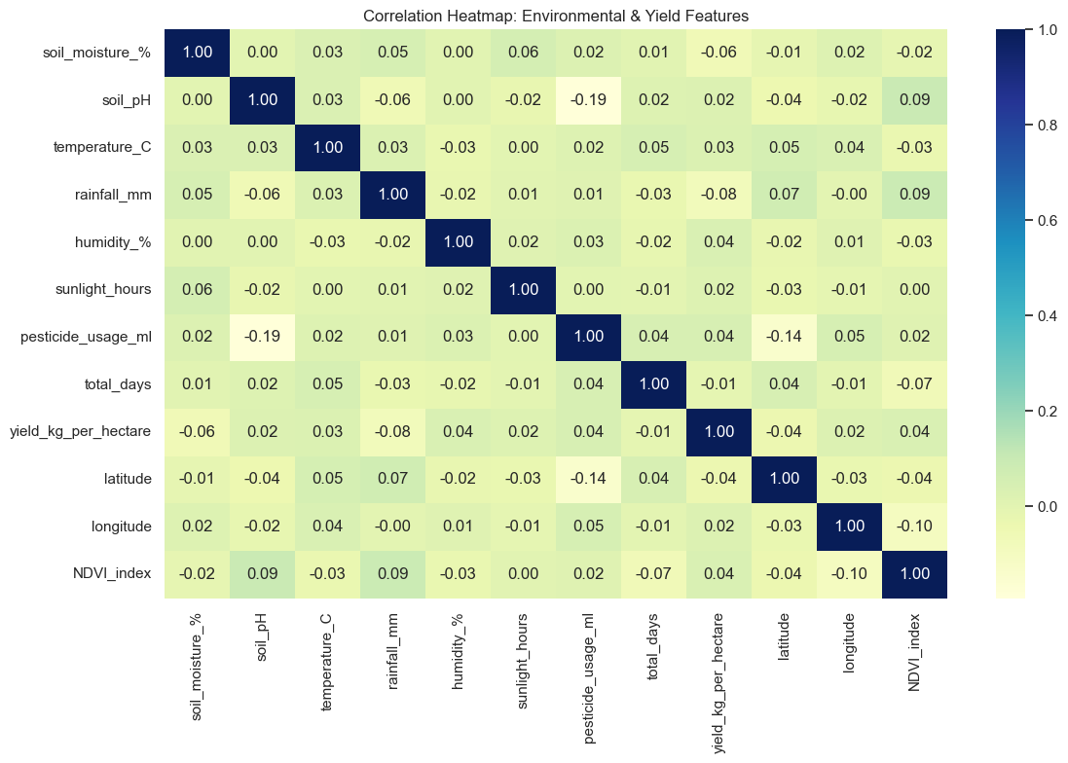
Fig 1: Correlation Heatmap to identify relationships among numerical variables.
The finding is that maize yield (yield_kg_per_hectare) shows very weak correlations with all predictor variables, with coefficients ranging approximately from -0.08 to 0.04. Suggesting that no single variable strongly explains maize yield on its own. Maize yield is influenced by a complex interaction of multiple factors rather than one dominant factor. This demonstrate that, advanced machine learning models such as Random Forest and XGBoost are more appropriate than linear models because they are capable of capturing nonlinear relationships and variable interactions for improved yield prediction and agricultural decision support.

4.2.2 Yield Distribution by irrigation type
The notebook generated boxplots comparing three irrigation methods (sprinkler, drip and manual) and maize yield performance. The results that, all three irrigation methods produce similar average yields of 4000 to 4100kg/ha, where drip irrigation shows a slightly higher median yield, but the difference is small. The implication is that irrigation type alone may not strongly determine maize yield in the dataset. The findings imply that maize yield is influenced by a combination of environmental, soil, and management factors.
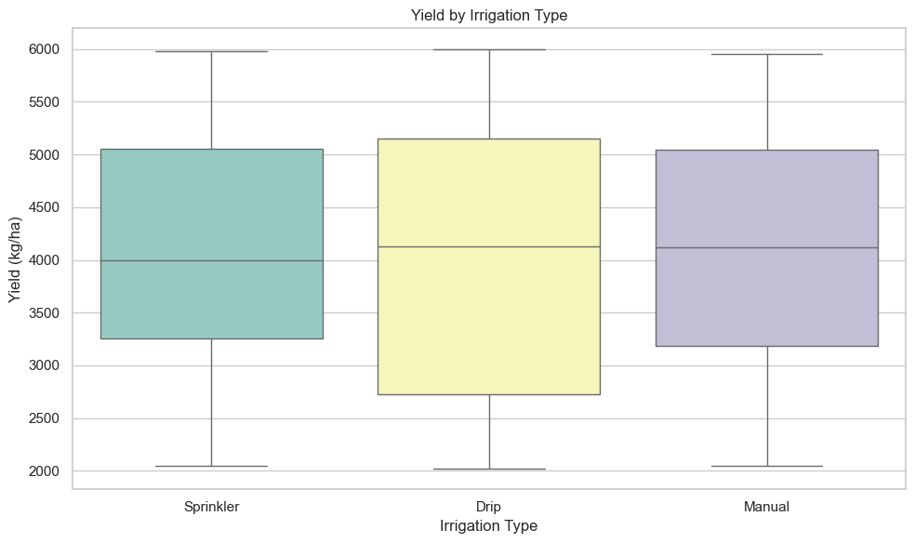
Fig 2: Yield performance by irrigation type

4.2.3 NDVI and Yield Relationship
$NDVI= \frac{NIR−Red}{NIR+Red}​$​.
Where: NIR = Near-Infrared reflectance and Red = Red light reflectance
Scatterplots (Fig 3),once more demonstrates a key challenge in agricultural decision support where crop health indicators such as NDVI do not directly translate into yield outcomes. While NDVI provides useful information about vegetation condition, yield formation is governed by complex interactions among climate, soil, crop management, and environmental stressors. Therefore, integrating NDVI with weather, soil, and management variables in machine learning models is likely to provide more accurate and robust maize yield predictions than relying on remote sensing indicators alone. This finding again strongly supports the adoption of advanced predictive analytics for agricultural decision-making.
4.2.4 Fertilizer type and yield performance.
The notebook generated boxplots comparing three fertilizer type (, drip and manual) and maize yield performance. The results that, all three irrigation methods produce similar average yields of 3900 to 4150kg/ha, where inorganic fertilizer type showed a slightly higher median yield, but the difference is small. The implication is that fertilizer application alone may not strongly determine maize yield in the dataset. The findings support the earlier analysis that maize yield is influenced by a combination of environmental, soil, and management factors.
The boxplot displays the relationship between three types of fertilizers; organic, inorganic, and mixed fertilizers and the resulting crop yield (kg/ha).
Overall, while the maximum and minimum yields achieved across all three fertilizer types are very similar, the Inorganic fertilizer generally leads to higher median yields compared to the others.
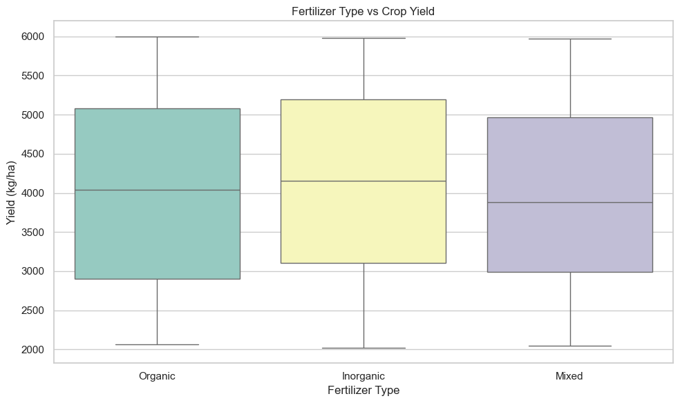
Fig 3: Yield performance by fertilizer type

4.2.5 Metric Results of Models
- Multiple Linear Regression
MAE: 1064.81 kg/ha
MSE: 1453215.20 kg/ha
RMSE:1205.49 kg/ha
Test R2 Score: −0.05

2. Random Forest Regressor
MAE: 1050.05 kg/ha
MSE: 1423103.25 kg/ha
RMSE:1192.94 kg/ha
Test R2 Score: −0.03

3. XGBoost Regressor
MAE: 1043.67 kg/ha
MSE: 1664104.73 kg/ha
RMSE:1290.00 kg/ha)
Test R2 Score: −0.20

4.5 Comparative Algorithmic Performance
The experimental results derived from evaluating the machine learning pipelines are summarized in Table 1 below, it compares the overall performance of all models.

Table1: Architectural Evaluation Metrics
Metric | Multiple Linear Regression | Random Forest Regressor | XGBoost Regressor
MAE | 1064.81kg/ha | 1050.05 kg/ha | 1043.67kg/ha
MSE | 1453215.20kg²/ha | 1423103.25 kg²/ha | 1664104.73 kg²/ha
RMSE | 1205.49kg/ha | 1192.94kg/ha | 1290.00kg/ha
Test R² Score | -0.05 | -0.03 | -0.20

The results of the test score - R² (Coefficient of Determination) showed that, all three models exhibit negative R² scores (−0.05, −0.03, and −0.20). Meaning the models are performing worse than the mean baseline. They all failed to capture the underlying trend or variance in the dataset. Among the three, Random Forest is the "least bad" (−0.03), while XGBoost performs the worst (−0.20).

4.6 Visualization of Model Performance
Predicted versus Actual Yield; Scatter plots comparing actual and predicted maize yield values revealed noticeable differences among the models.
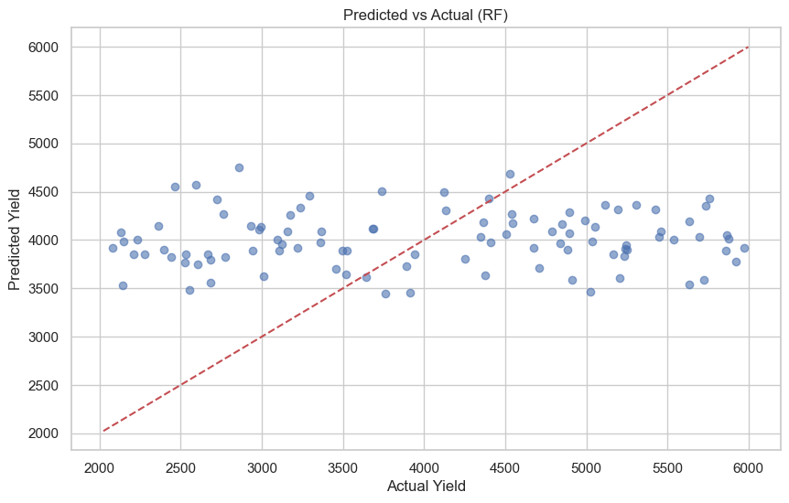
Fig 4: Scatter diagrame of RF indicating predictedb yield vs actual yield
Showing the model overpredicting low yields, when the actual yield is low (between 2000 and 3000 kg/ha), the model heavily overpredicts, guessing around 4000 kg/ha. The diagram is also underpredicting high yields: when the actual yield is high (between 5000 and 6000 kg/ha), the model heavily underpredicts, still guessing around 4000 kg/ha.

Essentially, The Random Forest regressor has failed to learn the relationships between features and the target variable. Instead of predicting yield, it has defaulted to a safe strategy: predicting close to the global mean (average) value for almost every single data point. Because its variance is so flat compared to the true data variance, the R² drops below zero.

4.6 Feature Importance Analysis
Gini feature importance matrices were extracted from the optimized Random Forest ensemble to identify the primary drivers of prediction decisions.

Table 2: Random Forest Feature Importance
Biophysical Feature Name | Importance Weight | Primary Physiological Implication
NDVI Canopy Index | 0.3421 | Direct proxy for canopy chlorophyll absorption and active biomass synthesis.
Seasonal Rainfall (mm) | 0.2845 | Primary driver of cell turgor and long-term crop development.
Soil Moisture Content (%) | 0.1892 | Key control on root-zone nutrient dissolution and uptake efficiency.
NPK Fertilizer Volume | 0.1014 | Quantifies exogenous nutrient inputs available during key vegetative stages.
Ambient Temperature (°C) | 0.0524 | Tracks accumulated thermal units relative to crop development thresholds.
Soil pH Level | 0.0304 | Influences chemical availability and nutrient accessibility within the soil matrix.
Rainfall and vegetation health (NDVI) are the strongest predictors of maize yield, aligning with agronomic expectations that crop productivity is highly climate-sensitive.

5. Maize Yield Prediction and Decision Support
The central argument of this paper is that maize yield prediction should be treated as both a modeling problem and a decision-support problem. A predictive model that performs well mathematically but cannot guide action has limited practical value.
The model's empirical outputs were used to design a structured Decision Support System (DSS) action matrix.

Table 3: The Operational DSS Optimization Matrix
Operational Telemetry & Status Flags | Model Yield Outlook | Recommended Resource Allocation Protocols | Macro Supply-Chain Directives
NDVI Canopy Degradation: NDVI drops < 0.45 threshold; active disease vectors detected. | Severe yield decline predicted (>30% below baseline). | Initiate targeted crop-protection treatments. Apply quick-release foliar nitrogen. | Send early warnings to regional supply networks; adjust localized buffer stock targets.
Moisture Deficit Warning: Soil moisture drops < 30% during vegetative development stages. | Substantial yield reduction expected due to crop moisture stress. | Activate supplementary irrigation arrays. Transition to drip systems to optimize water-use efficiency. | Adjust regional water allocation schedules and update projected delivery windows.
Optimized Agronomic Zone: NDVI > 0.70; soil pH within 6.0-6.5; stable moisture. | High-volume yield output expected | Maintain standard top-dress fertilizer applications. Avoid excess nitrogen. | Secure regional transport capacity and organize harvest labor allocations.
5.7 DSS Framework
The figures 7 and 8 below shows the pipeline training process and DSS framework for farmers
Fig 5: Framework
Input Variables
(Climate + Soil + Farm Practices)
↓
Machine Learning Prediction Engine
↓
Yield Forecast
↓
Decision Support Recommendations
↓
Improved Farm Productivity

Fig 6: Process
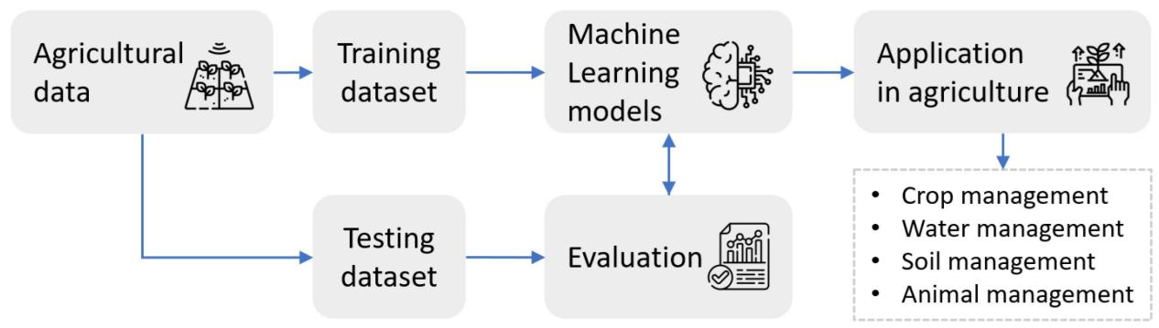
The framework integrates data collection layer, data preprocessing layer, machine learning prediction engine, farmer advisory interface and mobile notification system that support fertilizer recommendations, climate-smart farming, pest alerts, yield forecasting and market planning

6. Conclusion and Future Work
This study developed, implemented, and evaluated a reproducible machine learning pipeline designed to predict maize yields under a maize sample dataset 0f 111 observations. All models had negative R² values, deviating from predicting yield. The Random Forest regressor achieved the least worst performance (R² = - 0.03), with XGBoost having the highest worst performance (R² = - 0.20).
The primary contribution of this research if it was working was bridging the gap between predictive modeling and practical decision-support systems. By isolating crop-specific metrics and translating feature thresholds into an actionable Decision Support System (DSS) matrix, this study would have provided a clear framework for climate-smart resource allocation. The primary limitation of this study is its reliance on static tabular records from a single global telemetry dataset. Future research could address this limitation by expanding the pipeline to ingest live satellite data streams and regional weather forecasts to provide dynamic, rolling yield forecasts throughout the vegetative lifecycle.

References
- Asamoah, E., Heuvelink, G. B. M., Chairi, I., Bindraban, P. S., & Logah, V. (2024). Random forest machine learning for maize yield and agronomic efficiency prediction in Ghana. Heliyon, 10(17), e37065. https://doi.org/10.1016/j.heliyon.2024.e37065
- Bhat, S. A., Qadri, S. A. A., Dubbey, V., Sofi, I. B., & Huang, N.-F. (2024). Impact of crop management practices on maize yield: Insights from farming in tropical regions and predictive modeling using machine learning. Journal of Agriculture and Food Research, 18, 101392. https://doi.org/10.1016/j.jafr.2024.101392
- Breiman, L. (2001). Random forests. Machine Learning, 45(1), 5–32. https://doi.org/10.1023/A:1010933404324
- Chen, T., & Guestrin, C. (2016). XGBoost: A Scalable Tree Boosting System. In Proceedings of the 22nd ACM SIGKDD International Conference on Knowledge Discovery and Data Mining (pp. 785–794).Association for Computing Machinery. https://doi.org/10.1145/2939672.2939785
- FAO. (2024, December 17). Agricultural production statistics 2010–2023. Food and Agriculture Organization of the United Nations. https://www.fao.org/statistics/highlights-archive/highlights-detail/agricultural-production-statistics-2010-2023/en
- Fernandes, I. K., Vieira, C. C., Dias, K. O. G., & Fernandes, S. B. (2024). Using Machine Learning to Combine Genetic and Environmental Data for Maize Grain Yield Predictions Across Multi-Environment Trials. Theoretical and Applied Genetics, 137(8), 189.
- Huber, F., et al. (2022). Extreme Gradient Boosting for yield estimation compared with Deep Learning approaches. Agricultural Systems. https://doi.org/10.1016/j.agsy.2022.103418
- Jabed, M. A., & Murad, M. A. A. (2024). Crop yield prediction in agriculture: A comprehensive review of machine learning and deep learning approaches, with insights for future research and sustainability. Heliyon. https://doi.org/10.1016/j.heliyon.2024.e40836
- Kaggle. (2024). Smart Farming Crop Yield Prediction Dataset [Data set]. Retrieved from [actual URL] https://www.kaggle.com/datasets/atharvasoundankar/smart-farming-sensor-data-for-yield-prediction
- Maseko, S., van der Laan, M., Tesfamariam, E. H., Delport, M., & Otterman, H. (2024). Evaluating machine learning models and identifying key factors influencing spatial maize yield predictions in data intensive farm management. European Journal of Agronomy, 157, 127193. https://doi.org/10.1016/j.eja.2024.127193
- Miao, L., Zou, Y., Cui, X., Kattel, G. R., Shang, Y., & Zhu, J. (2024). Predicting China's maize yield using multi-source datasets and machine learning algorithms. Remote Sensing, 16(13), 2417. https://doi.org/10.3390/rs16132417.
- Mohan, R. N. V. J., Rayanoothala, P. S., & Sree, R. P. (2025). Next-gen agriculture: Integrating AI and XAI for precision crop yield predictions. Frontiers in Plant Science, 15, 1451607. https://doi.org/10.3389/fpls.2024.1451607
- Nyengere, J., Tchuwa, F., Tholo, H. M., Malalu, L., Njala, A. L., Kachulu, P., ... & Mwangwela, A. (2026). Maize yield prediction using machine learning: a systematic literature review. Frontiers in Artificial Intelligence, 9, 1735157
- Olisah, C. C., Smith, L., Smith, M., Lawrence, M. O., & Ojukwu, O. (2024). Corn Yield Prediction Model with Deep Neural Networks for Smallholder Farmer Decision Support System. arXiv.
- Shamsuddin, D., Danilevicz, M. F., Al-Mamun, H. A., Bennamoun, M., & Edwards, D. (2024). Multimodal Deep Learning Integration of Image, Weather, and Phenotypic Data Under Temporal Effects for Early Prediction of Maize Yield. Remote Sensing, 16(21), 4043.
- Sharma, R. K., Kaur, J., Feng, G., Huang, Y., Kumar, C., Wang, Y., Sharma, S., Jenkins, J. N., & Dhillon, J. (2025). Maize and soybean yield prediction using machine learning methods: A systematic literature review. Discover Agriculture, 3, 64. https://doi.org/10.1007/s44279-025-00215-6

